# **Jenkins Declarative pipeline Script**

**Pre-requisites**

Step 1 — Launch an Ubuntu(22.04) T2 Large Instance

Install java:

sudo apt update

sudo apt install fontconfig openjdk-17-jre

java -version

openjdk version "17.0.8" 2023-07-18

OpenJDK Runtime Environment (build 17.0.8+7-Debian-1deb12u1)

OpenJDK 64-Bit Server VM (build 17.0.8+7-Debian-1deb12u1, mixed mode, sharing)

Install Jenkins:

sudo wget -O /usr/share/keyrings/jenkins-keyring.asc \

https://pkg.jenkins.io/debian-stable/jenkins.io-2023.key

echo deb [signed-by=/usr/share/keyrings/jenkins-keyring.asc] \

https://pkg.jenkins.io/debian-stable binary/ | sudo tee \

/etc/apt/sources.list.d/jenkins.list > /dev/null

sudo apt-get update

sudo apt-get install jenkins

sudo systemctl start jenkins

sudo systemctl enable jenkins

Once Jenkins is installed, you will need to go to your AWS EC2 Security Group and open Inbound Port 8080, since Jenkins works on Port 8080.

Now, grab your Public IP Address

<EC2 Public IP Address:8080>

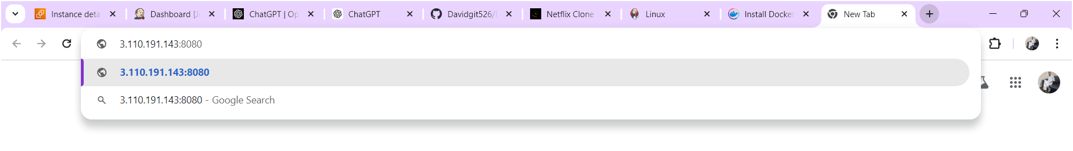

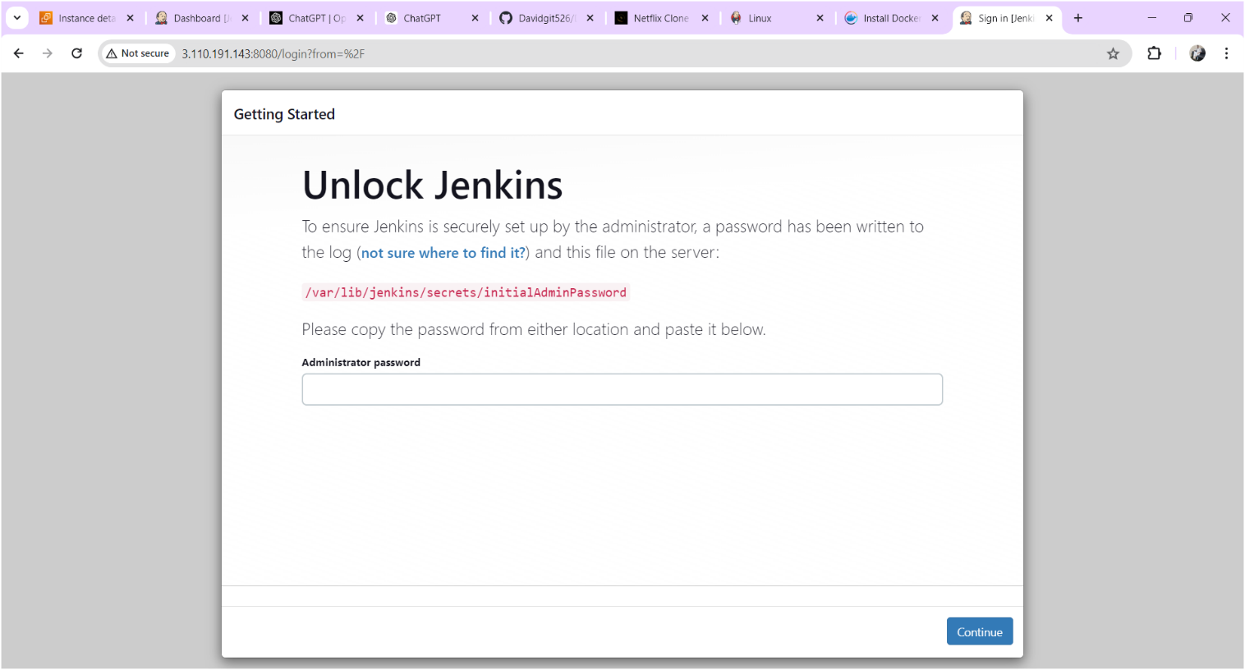

Copy the text which is mentioned in yellow colour box above and paste it using command “cat /var/lib/jenkins/secrets/initialAdminPassword” on your terminal after you will get below output.

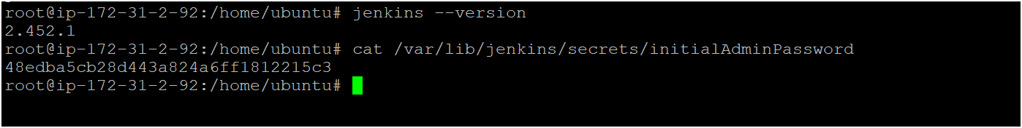

Copy the password for login to jenkins as shown above image

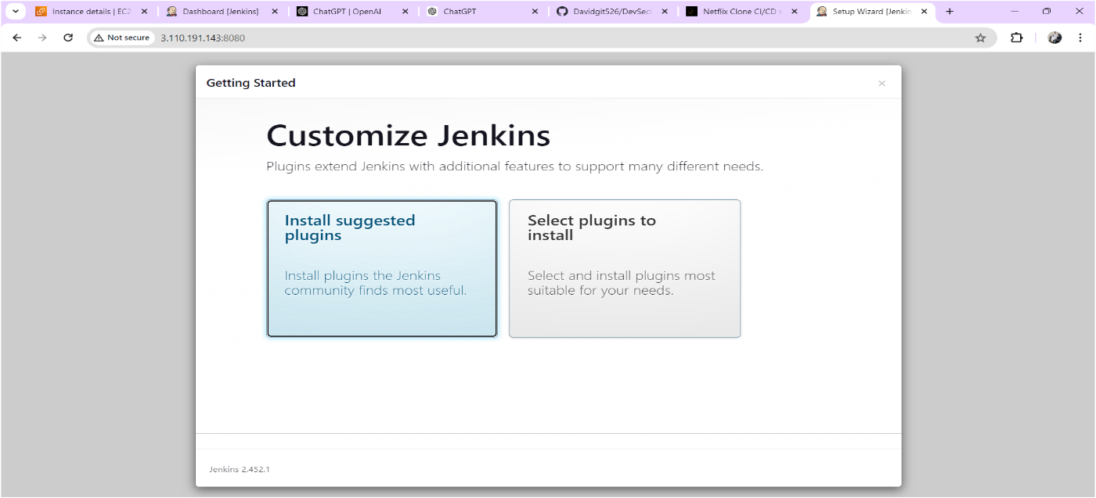

Click on Suggested plugins as shown above image after you will get output as shown below image

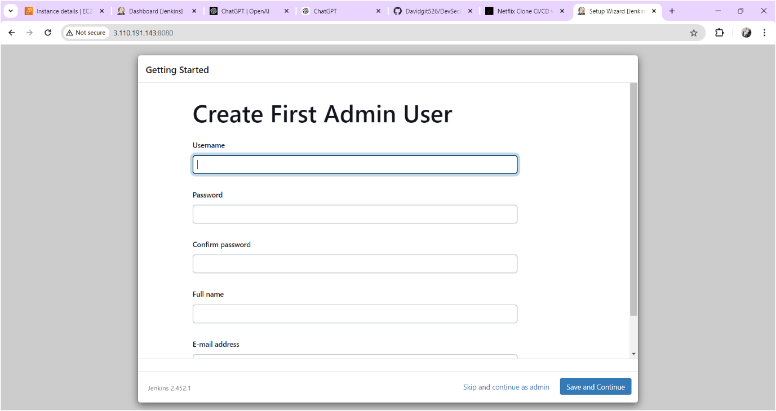

Click on skip and continue as admin

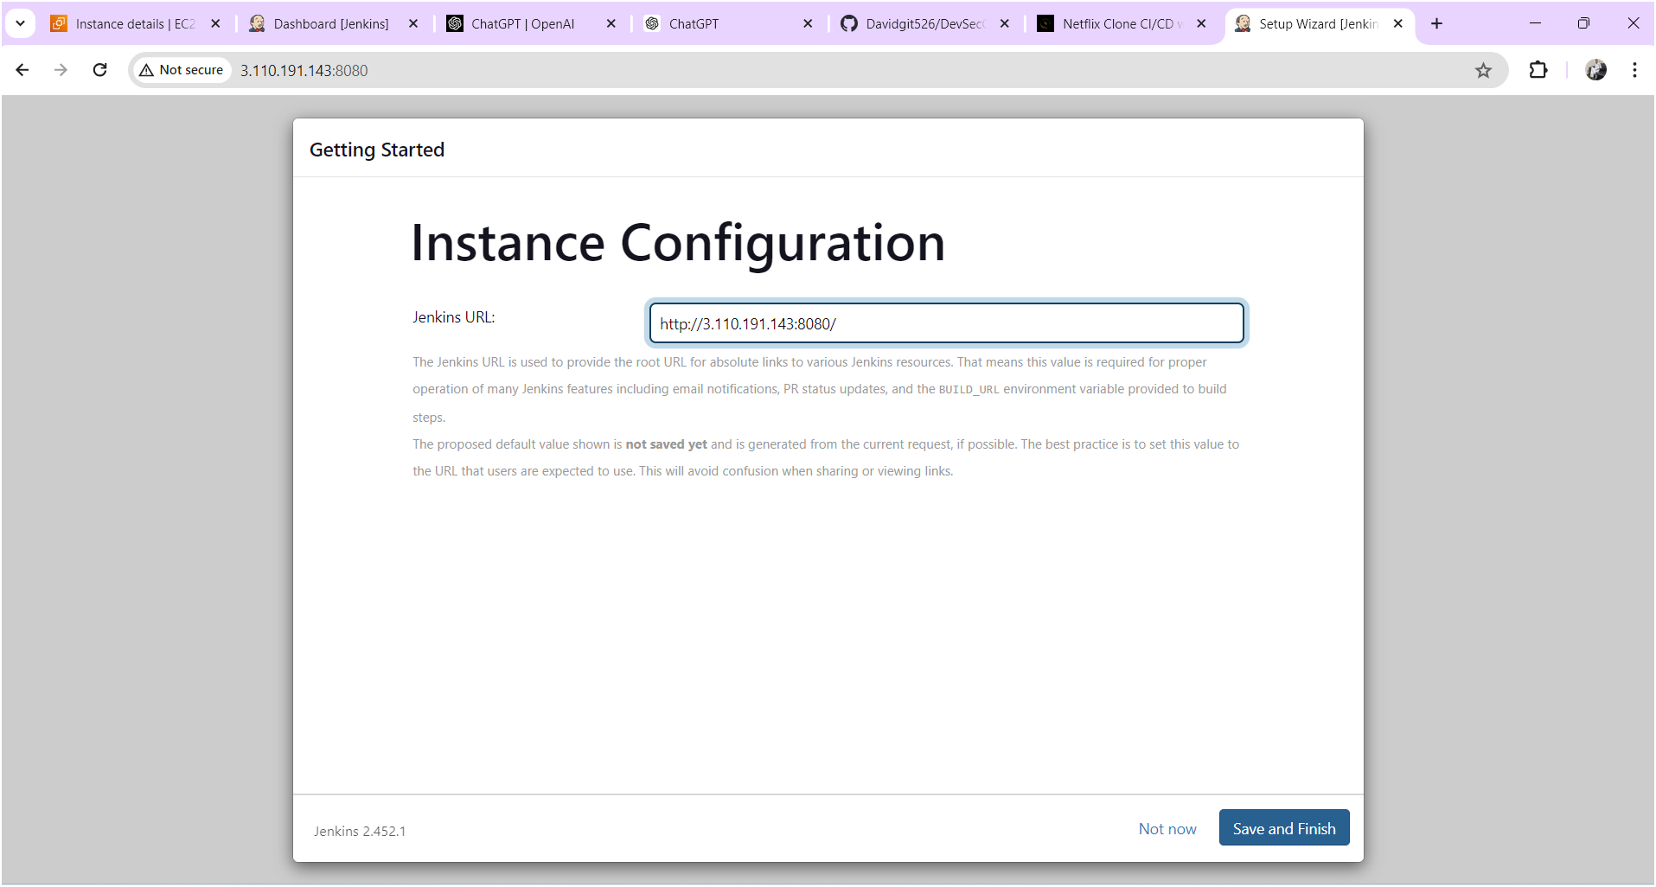

Click on save and finish

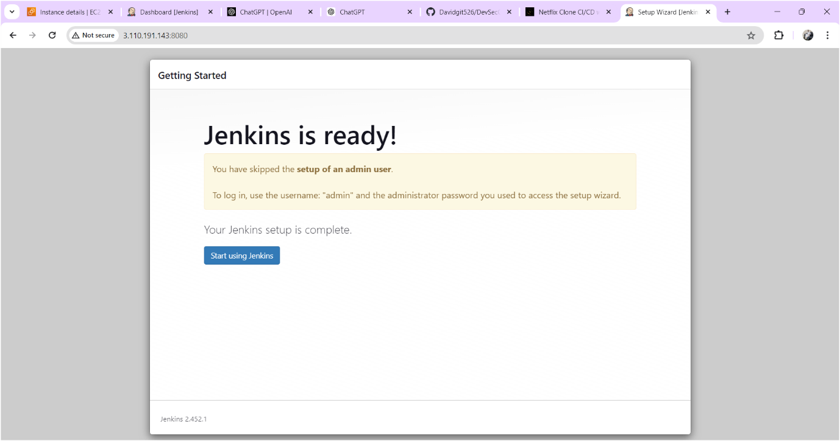

Click on start using jenkins

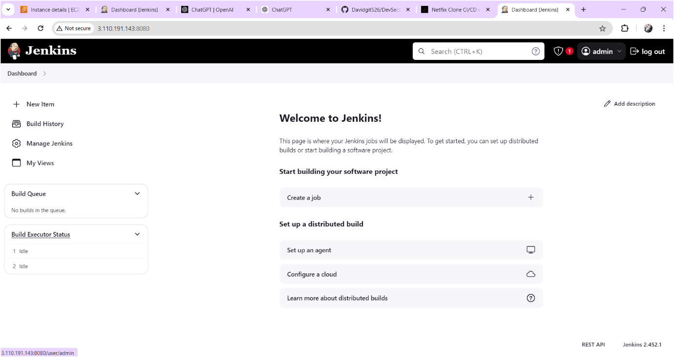

Now you should change the password for that

Click on admin🡪click on configure find password there you can change the password whatever you want. Output sown as below image

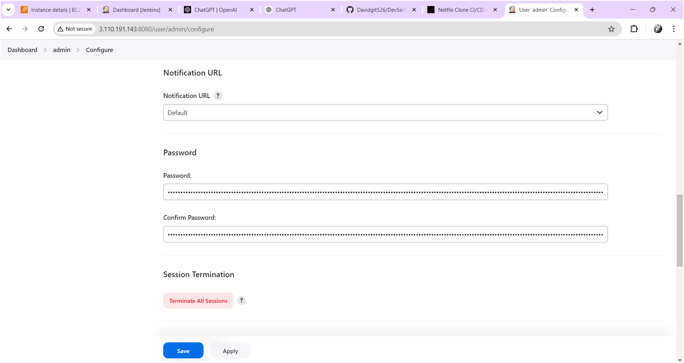

After changing the password click on **apply** and **save** after output will come as shown below image.

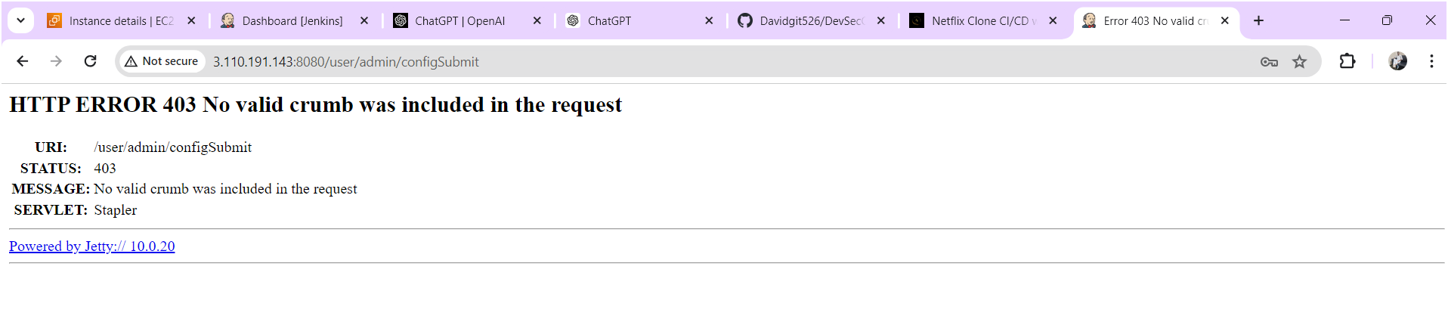

Now refresh the page after output will come as shown below image

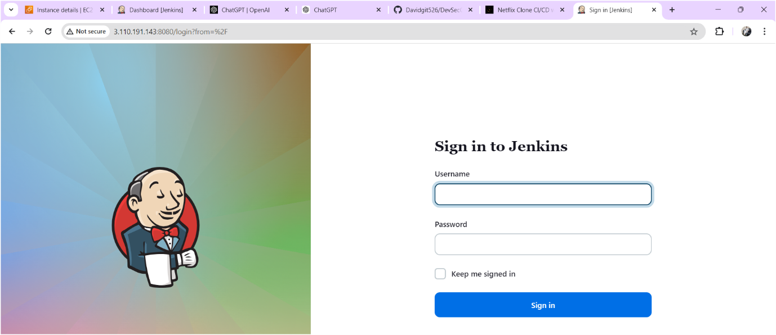

Login to the jenkins with your updated credentials after you will get jenkins home page.